University of Computer Studies

(Mandalay)

Presented by

**Flower–Mdy-Geo**

Date 4/9/2018

**A PROJECT REPORT ON**

**“Apps in Myanmar”**

FOR

**Geo Mandalar Investment & Technology Co ltd;**

SUBMITTED IN PARTIAL

FULFILLMENT OF INTERNSHIP

PROJECT

UNDER THE GUIDANCE OF

Director

***U Ravi chhabra***

Supervisor

***Daw Min Min Su***

**SUBMITTED BY**

Ma Aye Nandar Tun

Ma Aye Thandar Aung

Ma Zin Mar Nwe

Ma Nann Lae Lae Aung

Ma Thin Mar Win

Mg Kyaw Zin Aung

**I**

**Group Members**

|  |  |  |  |
| --- | --- | --- | --- |
| Roll No | Name | Signature | Date |
| 5CS-69 | Ma Aye Nandar Htun |  |  |
| 5CS-72 | Ma Aye Thandar Aung |  |  |
| 5CS-70 | Ma Zin Mar Nwe |  |  |
| 5CS-71 | Ma Nann Lae Lae Aung |  |  |
| 5CS-59 | Ma Thin Mar Win |  |  |
| 5CS-57 | Mg Kyaw Zin Aung |  |  |

**Supervisor Signature**

**Daw Min Min Su**

**II**

**CONTENTS**

**Page**

**A project report on I**

**Group members II**

**Lists of Figures IV**

**Acknowledgments V**

**Abstract VI**

**Declaration VII**

**CHAPTER 1 INTRODUCTION**

1.1 Introduction 1

1.2 Objectives of the projects 1

1.3 What is Github? 1

1.4 Advantages of using Github 2

1.5 Disadvantages of using Github 2

1.6 Step1 3

**CHAPTER 2**

2.1What is Gitbash? 5

2.2What is Git? 5

2.3 What is Python 6

2.4Step2 6

**III**

**CHAPTER 3**

3.1What is Firebase? 8

3.3Advantages of using Firebase 9

3.3Disadvantages of using Firebase 9

3.4Step3 10

**CHAPTER 4**

4.1 Step4 12

4.2 Advantages of projects 22

4.3Disadvantages of projects 22

4.1Conclusion 23

**IV**

**List of Figures**

Figures Page

1.1 Level1 3

1.2 Level2 4

1.3 Level3 4

2.1 Python exercise 6

2.2 Python exercise 7

3.1 Firebase 8

3.2 Design1 10

3.3 Design2 11

4.1 Home page 12

4.2 Navar page 13

4.3 Login page 14

4.4 Admin page 15

4.5 Top Apps 16

4.6 Latest Apps 17

4.7 Home Page 18

4.8 Top Apps 19

4.9 Latest Apps 20

4.10Usecase diagram 21

**V**

**Acknowledgments**

First of all, we would like to express our sincere thanks and appreciation to all persons, whose guidance aided directly toward the success of this project.

We would respectfully thank and appreciate **to U Kyaw Zwa Soe**, Rector of University of Computer Studies (Mandalay), and our pro-rector **Dr San San Tint.**

And then, we would like to describe our sincere thank **Director U Ravi Chhabra,** CEO of Geo Mandalar Investment & Technology Co Ltd, for his trust to give us such a heavy responsibility project.

We are deeply thankful to our supervisor **Daw Min Min Su**, Department of Mathematics, University of Computer Studies (Mandalay), for help valuable guidance and encouragement that have strengthend our focus, presentation and correctness of the project.

We would like to express our grateful thank to all teachers at University of Computer Studies (Mandalay) for their helpful advice.

**VI**

**Abstract**

This is the processes of our internship program during the internship period for four months. We need to create account such as github, heroku and firebase. We also use gitbash software.

In the end, there is a briefing about the internship project that was assigned during the required internship to me.

**VII**

**Declaration**

We declare that this project is as the instructions of our Director **U Ravi Chhabra**. Sometimes, we search some data from google.

Project Details

|  |  |
| --- | --- |
| Project Title | Firebase(Apps in Myanmar) |
| Project ID | Geo Mandalay Internship |

Software Requirements

-Gitbash

-Sublimetext

**VIII**

**CHAPTER 1**

**INTRODUCTION**

**1.1 Introduction**

Apps in Myanmar will involve various applications in Myanmar.Users can download the application and also see details that related applications.

**1.2 Objectives of the projects**

-We aim for users to find the application they want to use easily and quickly on our website.

-Users can save their time because we collect many application in the same place.

-By using our applications, we think users will be more convenient than before.

**1.3 What is GitHub?**

GitHub is a web-based hosting service for version control using Git. It is mostly used for computer code. It offers all of the distributed version control and source code management functionality of Git as well as adding its own features. Github is free to use for public and open source projects.

Link here-

<https://github.com>

**1**

We have own profile on Github .The link for each members are :

<https://AyeNandar.github.io>

<https://AyeThandarAung.github.io>

<https://ZinMarNwe.github.io>

<https://thinmarwin.github.io>

<https://KyawZinAung12.github.io>

<https://Nannlaelaeaung.github.io>

**1.4 Advantages of using Github**

1.It provides a backup of your files.

2.It gives you a visual interface for navigating your repos .

3.It gives other people a way to navigate your repos.

4.It makes repo collaboration easy .

5.It provides a light weight issue tracking system.

**1.5 Disadvantages of using Github**

1.It can’t create private repositories for free.

**2**

**1.6 Step1**

First, the director lets us to play the Vim Adventure Game to practice the keys that used in gitbash. Link Here-

<https://vim-adventures.com>

eg:

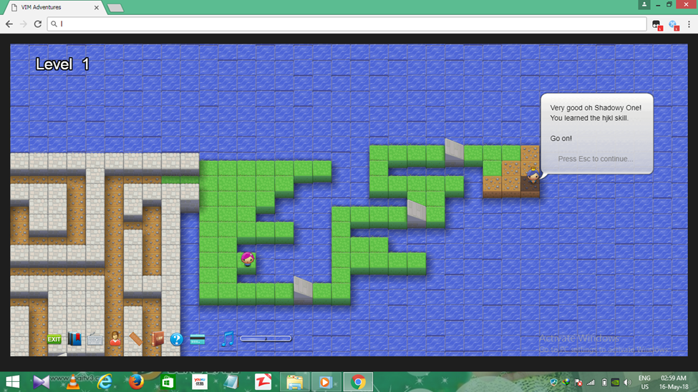

**Fig1.1.: Level1**

**3**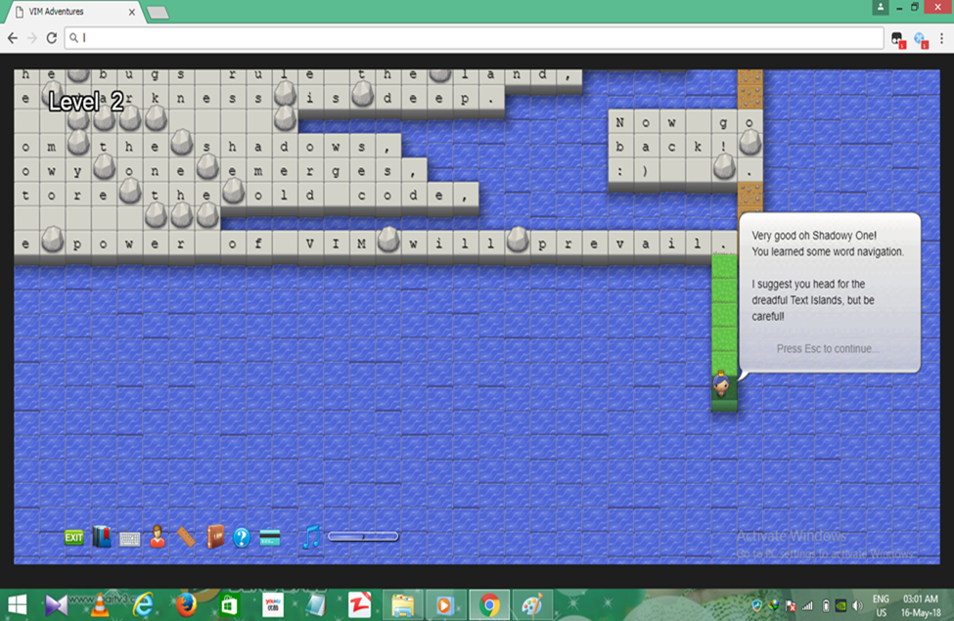

Fig 1.2: Level2

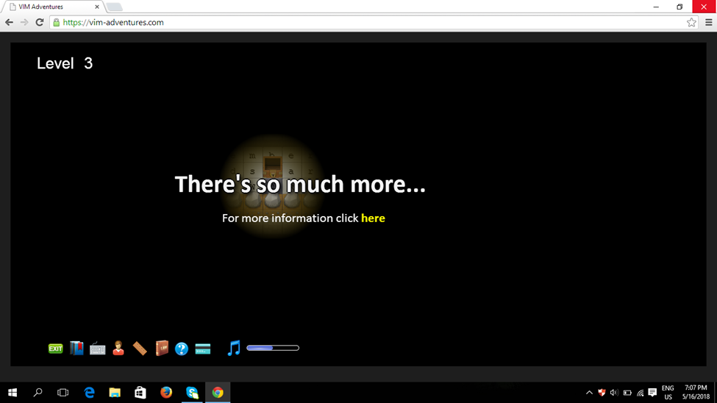

Fig 1.3 : Level3

**4**

**CHAPTER 2**

**2.1 What is Gitbash?**

Gitbash for windows is a package that is comprised of two parts: git :It is a version control system which tracks the file changes , commonly used for programming .bash: It is a unix shell command line interface commonly used in different linux machines.

**2.2 What is Git?**

Git is a version control system for tracking changes in computer files and coordinating work on those files among multiple people .As a distributed revision control system , it is aimed at speed, data integrity, and support for distributed , non-linear workflows.

git add –

C:\Users\Aye Nandar Htun\Pictures\git add.JPG

git commit –

C:\Users\Aye Nandar Htun\Pictures\git commit.JPG

git push-

C:\Users\Aye Nandar Htun\Pictures\git push.JPG

**5**

**2.3 What is python?**

Python is an interpreted high-leve l programming language for general purpose programming.Created by Guido van Rossum and first released in 1991, Python has a design philosophy that emphazes code readability, notably using significant whitespace.You can use python for developing desktop GUI application. Also , Python , as a high level programming language , allows you to focus on core functionality of the application by taking care of common programming tasks .

**2.4 Step2**

We have to learn and practice python exercise run with Gitbash, and then upload on Github.

**Example:**

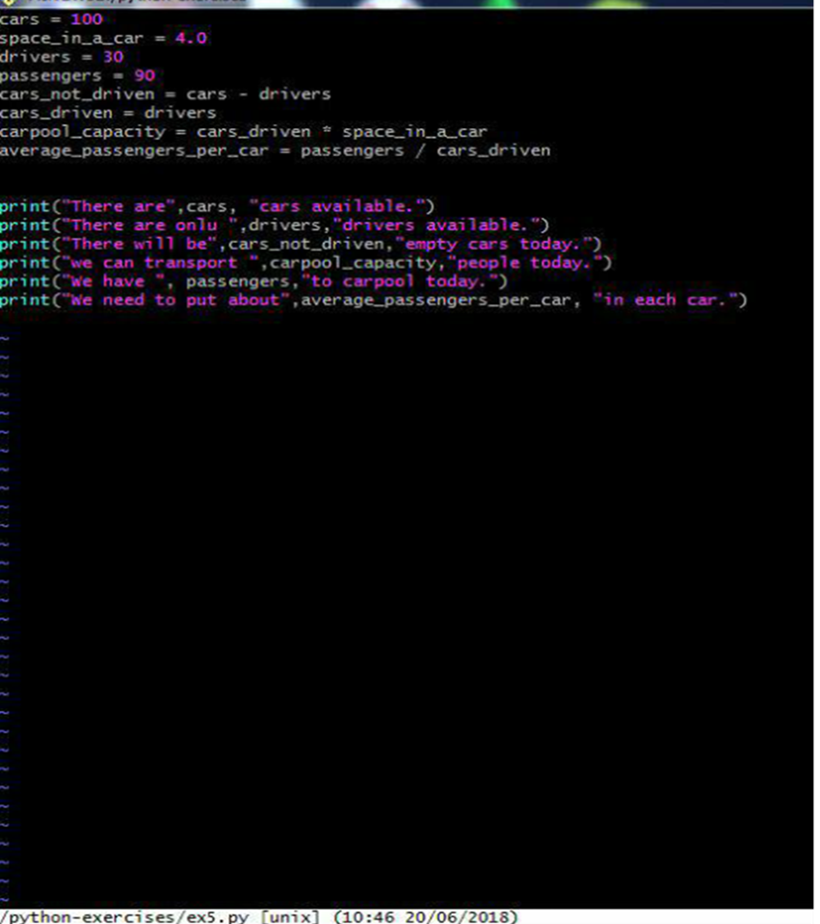

Fig2.1 Python exercise

**6**

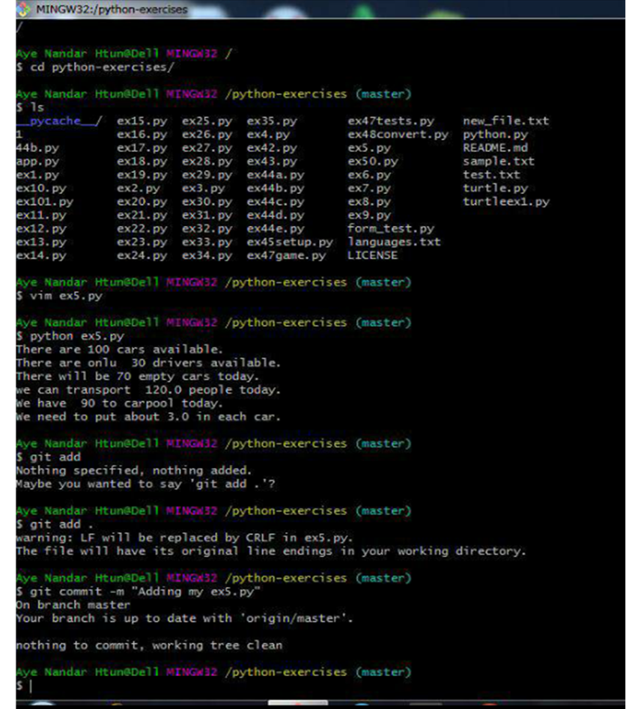

Fig2.2 Python exercise

**7**

**CHAPTER 3**

**3.1 What is Firebase?**

Firebase allows you to build apps which need authentication , database, file storage, analytics and server side functionality without having to own and manage infrastructure and software required for server side support. Firebase is Back-end as a services owned by Google which provides server-less back-end to the app developers.

Link here:

<https://firebase.com>

Or

<https://firebase.google.com>

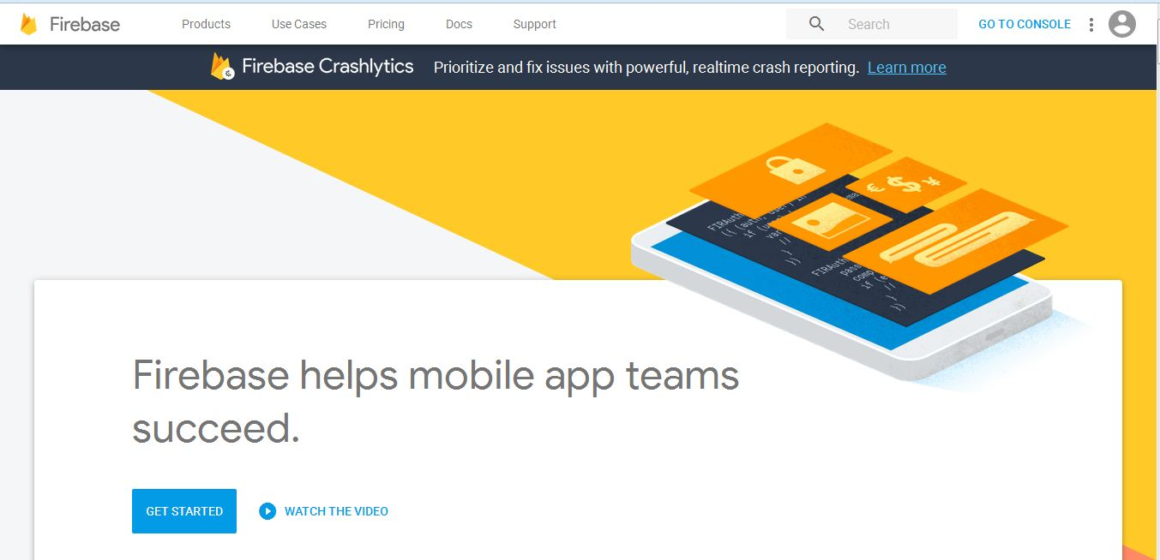

Fig 3.1: Firebase

**8**

**3.2 Advantages of using Firebase**

1.It requires minimal setup and accessing data and files is easy.

2.It has a real-time robust API

3.It provides high security on user

4.Doesn’t need server-side infrastructure to power the apps

**3.3 Dsiadvantages of using Firebase**

1.It is an open source software

2.For people who are used to SQL database, Firebase uses a NoSQL

(not –only SQL) database and mirgrating can be an issue.

3.Has limited indexes.Thus, developers need to build them

**9**

**3.4 Step 3**

We have to practice some design to create our main project with firebase.

Eg:

<https://geo-flower2.firebaseapp.com>

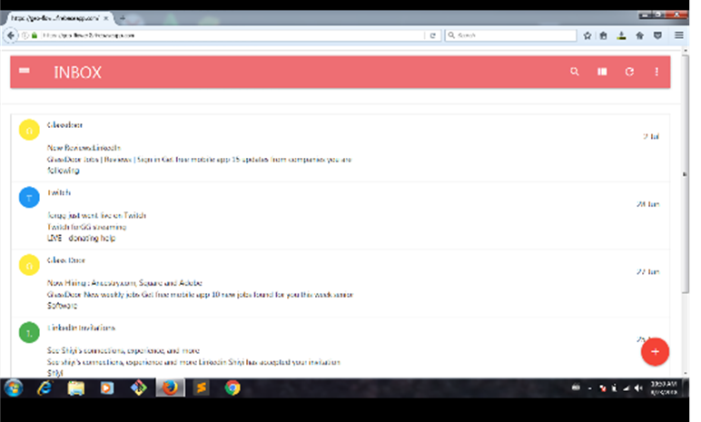

Fig 3.2: Design1

**10**

<https://mockery1-a.firebaseapp.com>

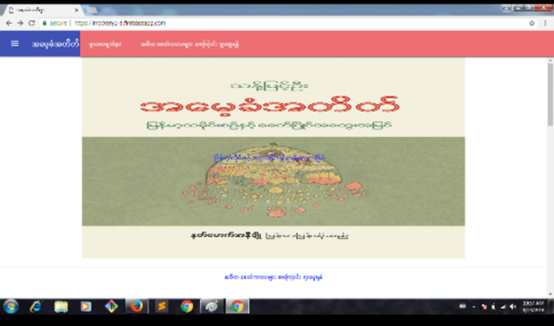

Fig3.3 Design2

11

**CHAPTER 4**

**4.1 Step4**

**Our project’s name is “App in Myanmar”. This is the collection of some famous applications in Myanmar. You can see it through the following link.**

[**https://shweweb02.firebaseapp.com**](https://shweweb02.firebaseapp.com)

**Desktop Version:**

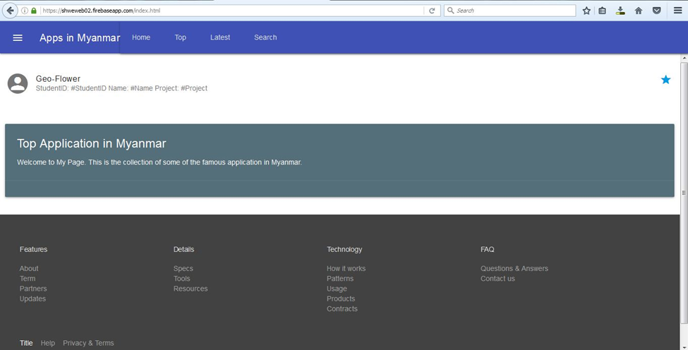

**Fig 4.1 :Home page**

**12**

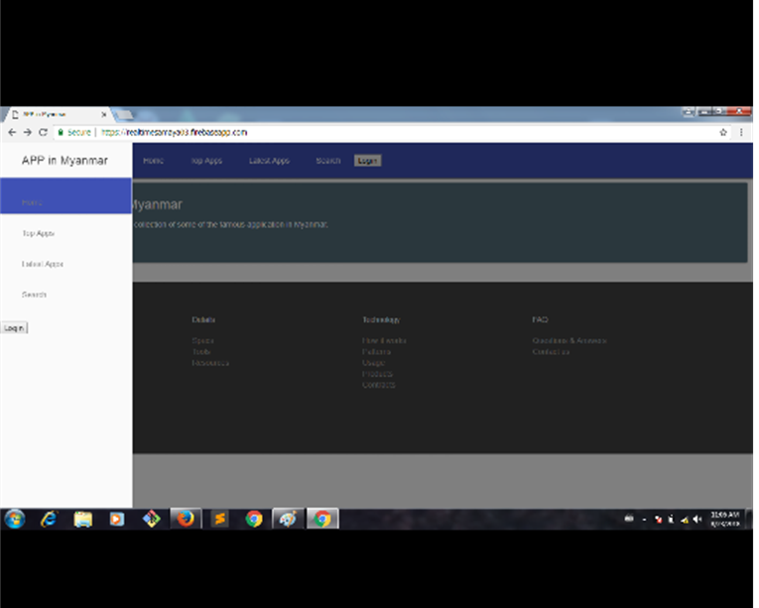

Fig 4.2 :Navbar page

13

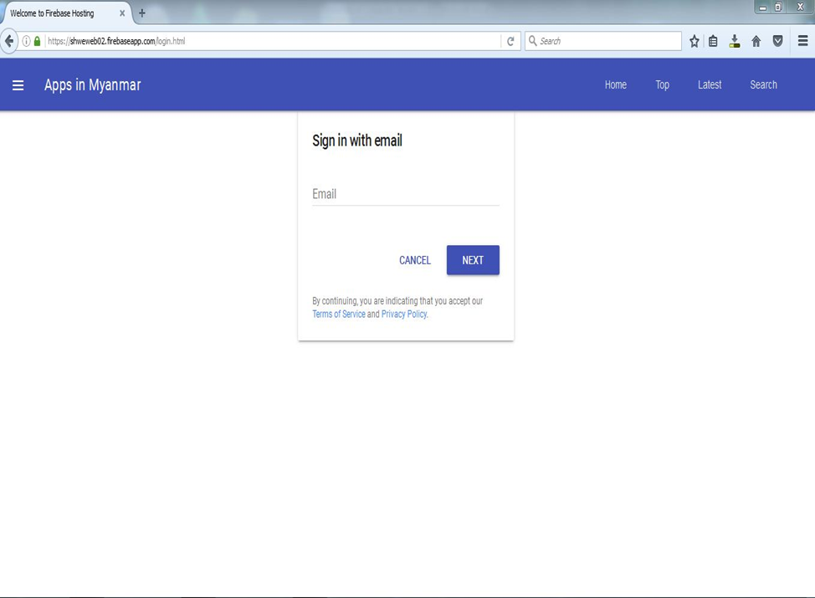

Fig 4.3:Login page

**14**

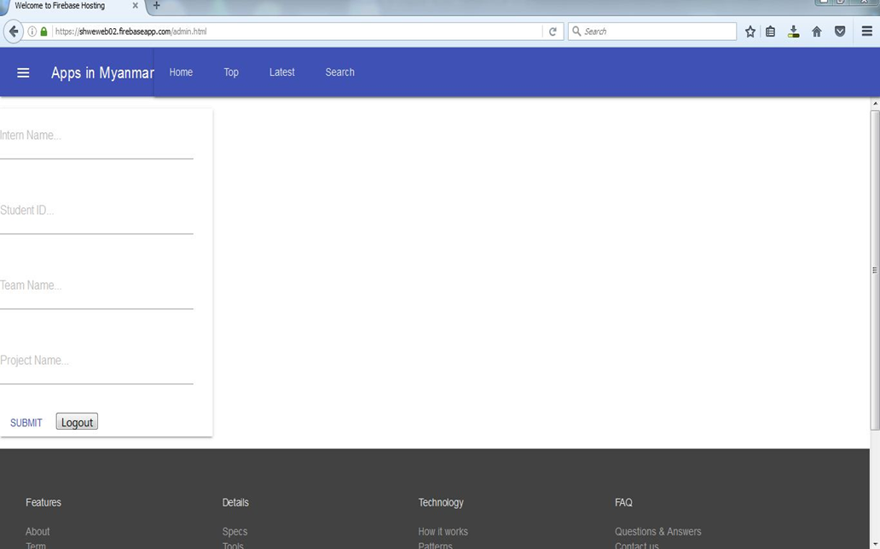

Fig 4.4:Admin page

**15**

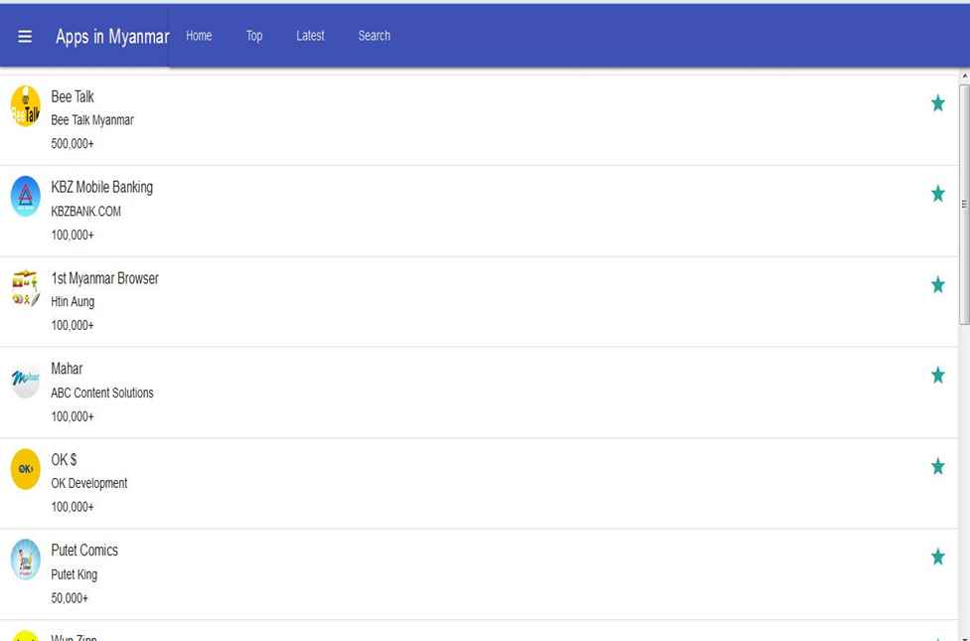

Fig 4.5 :Top Apps

**16**

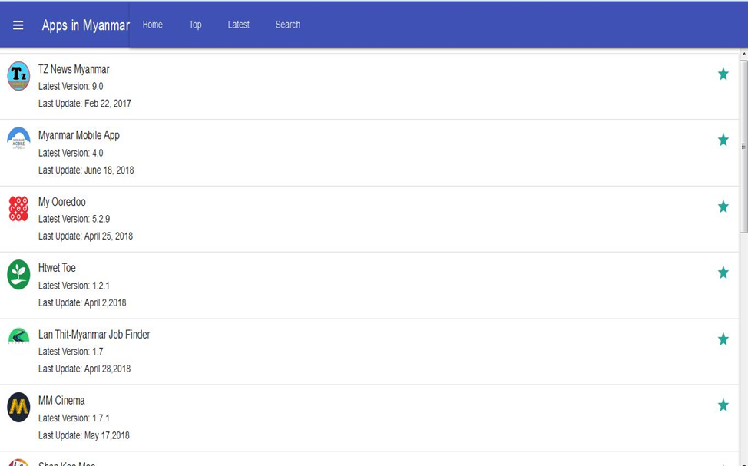

Fig 4.6:Latest Apps

**17**

Phone version

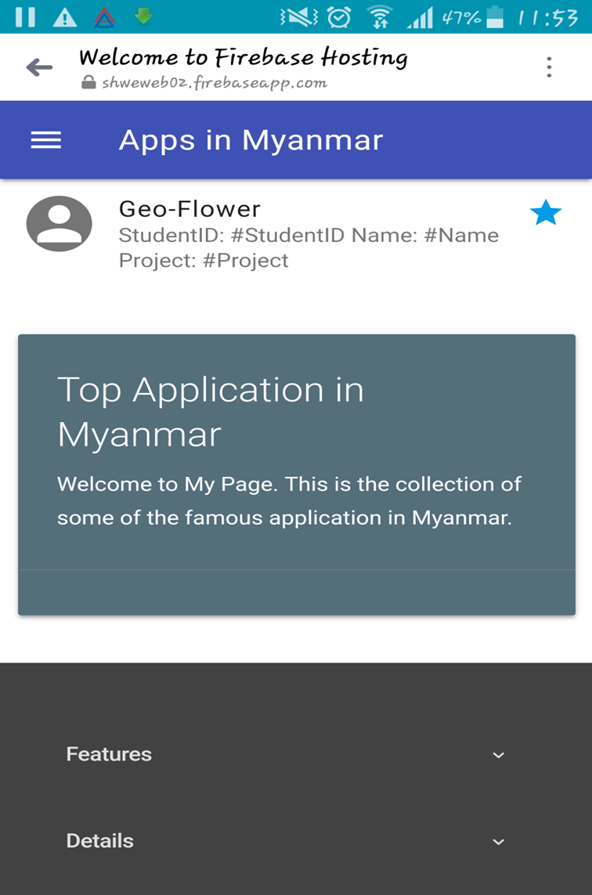

Fig 4.7:Home Page

**18**

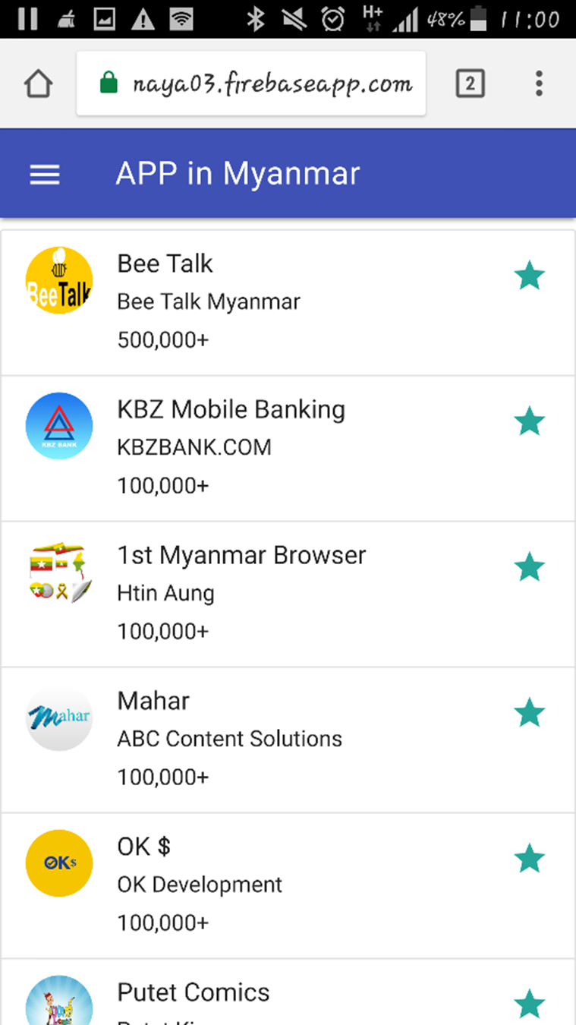

Fig 4.8:Top Apps

**19**

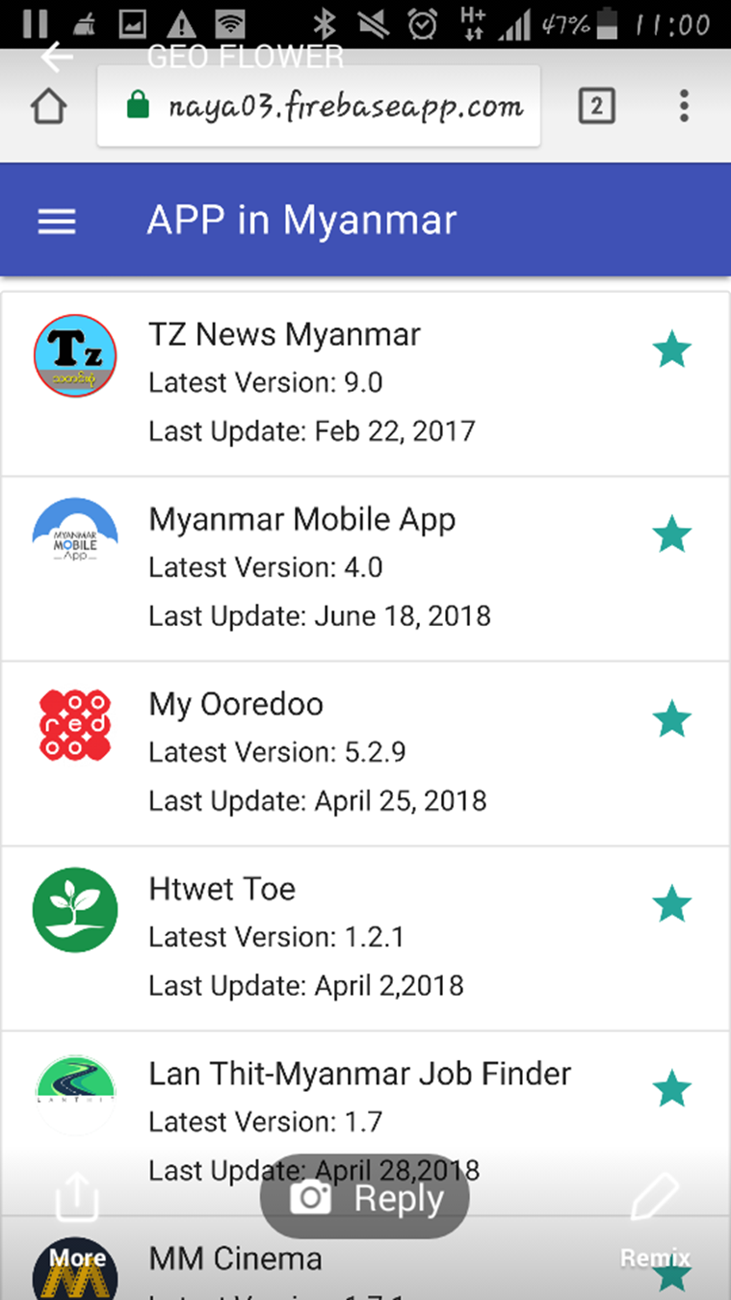

Fig 4.9:Latest Apps

**20**

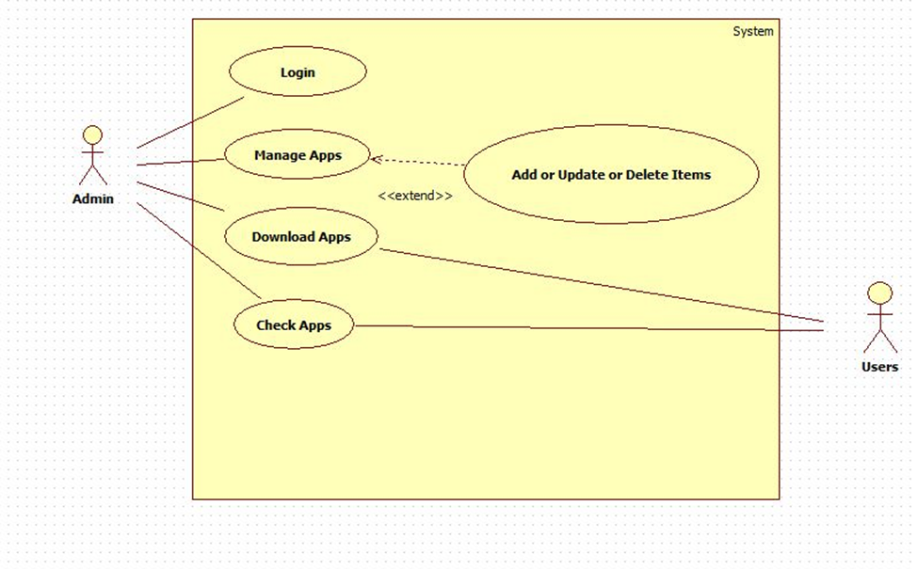

Fig4.10::Use Case diagram

**21**

**4.2 Advantages of the project**

**The proposed system offers the following advantages:**

**-**The required applications can be easily downloaded.

**-**Applications are becoming so functional and popular among people.

**4.3 Disadvantages of the project**

**-The cost of computer hardware and software programs can be expensive.**

**-As mobile tablets use wireless network, they can disconnect with**

**network if wifi fails.**

**22**

**CONCLUSION**

This internship programme is very useful for us because we can get more experience and knowledge about the real working environment.With join this internship we also can make new relations with other organizations or company.

The most important thing is we can improve our communication skills, also we can have more networking.In class we just know the theory, but in this internship we can practice all the theory in the real work.

**References:**

[**www.google.com**](http://www.google.com)

[**https://getmdl.io**](https://getmdl.io)

[**https://learnpythonthehardway.org/python3**](https://learnpythonthehardway.org/python3)

[**https://materializecss.com**](https://materializecss.com)

**23**

**The End.**

**Thanks for Everyone!**